AWS Document

To create account:

URL :https://aws.amazon.com/

* Create free account followed by the steps
* Login with credentials.
* Enter IAM In search box to create user

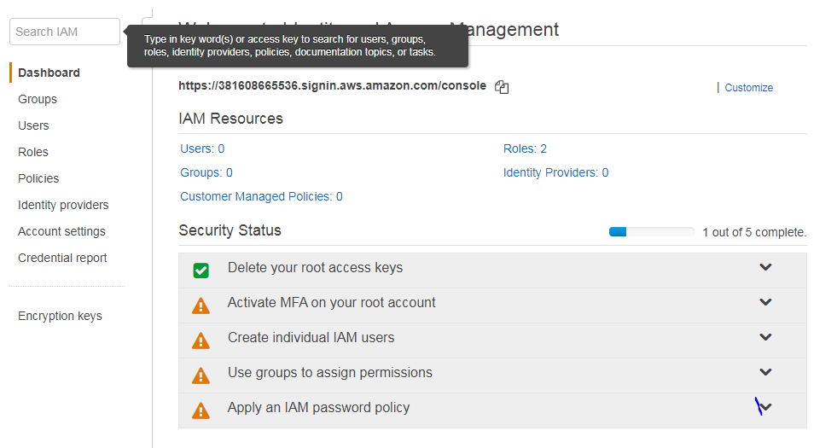

To Create Users:

* Click on users 🡪 Add users🡪Enter User Name🡪Select AWS Management Console Access🡪Select Attach existing policies directly
* In that Attach existing policies directly select [AdministratorAccess](https://console.aws.amazon.com/iam/home?#/policies/arn%3Aaws%3Aiam%3A%3Aaws%3Apolicy%2FAdministratorAccess) check box
* Click on Next and click on create user



Multi Factor Authentication (MFA):

* Goto users 🡪 click on security Credential tab🡪goto Assigned MFA device-🡪click on manage🡪 scan barcode in your device

**Note :** required Google authentication app in your mobile

<https://vikranth89.signin.aws.amazon.com/console>

Machine1 Instance ID: [i-00bfee4c780e74517](https://us-east-2.console.aws.amazon.com/ec2/v2/home?region=us-east-2#Instances:search=i-00bfee4c780e74517;sort=instanceId)

User Name:vikranth89

User vikky

Psw:Nihalreddy@89

1:Create Instances

2. Assign IPS

3.Create Security groups

4.Load Balancer

1:Create Instances:

It is like machine to create virtual machine

Goto instances-🡪Launch Instace🡪select OS (Redhat)🡪Instance Type(t2)🡪Instnce Setting(Zone selection & Monitoring and Public IP , Teminte protection, user Data (sricpts))-🡪vlume(patrician)🡪Tag🡪security group🡪view& launch

2. Assign Elastic IPS

Create privte Ip followed by the steps

3.Create security Groups:

Inbound and outbound rules

To assign security groups goto Instace-🡪right click on instance-🡪 goto network🡪 change security group.

**S3(Simple Storage Service) :**